Asiqul Hoque

Homework 7

Section 1 Lesson 1: Case and Character Manipulation

**Vocabulary**

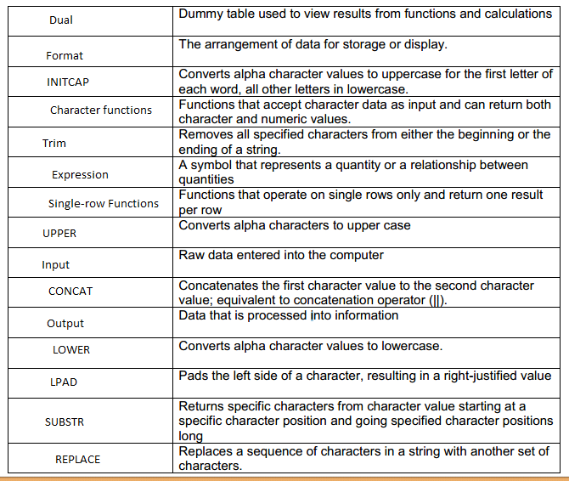

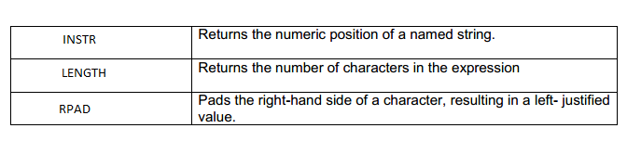

1. SELECT CONCAT('Oracle ', 'Internet')||' Academy' AS "The Best Class"   
FROM DUAL;



2. SELECT SUBSTR('Oracle Internet Academy', 13,3)AS "The Net"   
FROM DUAL;



3. SELECT LENGTH('Oracle Internet Academy')AS "length"   
FROM DUAL;



4.SELECT INSTR('Oracle Internet Academy', 'I')AS "position"   
FROM DUAL;



5. SELECT LPAD('Oracle',10,'*')||LPAD('Internet',12,'*')||RPAD(LPAD('Academy',11,'*'),15,'*')AS "LPAD_STRING"   
FROM DUAL;



6. SELECT RPAD('Oracle',9,'$')||RPAD('Internet',11,'$')||'Academy' AS "RPAD_STRING"   
FROM DUAL;



7. SELECT REPLACE('Oracle Internet Academy', 'Internet','2004-2005') AS "The Best Class"   
FROM DUAL;



8. SELECT order_date, LPAD(ORDER_TOTAL,7,'$')AS "TOTAL"   
FROM f_orders;



9. SELECT UPPER(first_name) ||' '|| UPPER(last_name) ||' '|| UPPER(address)||' ' ||UPPER(city) ||', '||UPPER(state)||' '||zip AS "ADDRESS"   
FROM f_customers   
WHERE id = 456;



10. SELECT SUBSTR(first_name, 1,1) || last_name AS "Name", salary, department_id   
FROM employees   
WHERE department_id = 20;

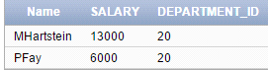

//Hard coded value

SELECT SUBSTR(first_name, 1,1) || last_name AS "Name", salary, department_id   
FROM employees   
WHERE department_id = :dept_id;



// Using Subsitution variable

11.SELECT department_id, department_name, location_id   
FROM departments   
WHERE department_name = :deptname;



12. SELECT *   
FROM employees   
WHERE SUBSTR(hire_date, 4, 3) = :month;

